Empirical Formula of Sodium Bicarbonate

Student Name: Lukas Aung
Date: 11/14/25
Class: Pre-IB/Honors Chemistry - Period 2
Instructor: Toni Green

Introduction
In the 18th century, Antoine Lavoisier, today known as the father of modern chemistry, was credited with the discovery of decomposition reactions, along with other kinds of reactions (Libretexts, 2025). His experiments with mercuric oxide demonstrated that the compound could be broken down to mercury and oxygen by heating it.
The general form of a decomposition reaction is
AB → A + B
in which, as one could most likely infer, AB is the starting compound, and A + B are its components. Most decomposition reactions require an input of energy, which could come in the form of a catalyst, electricity, or most commonly, heat (Libretexts, 2025).
The decomposition reaction is also a stoichiometric equation, meaning that the equation is balanced. With an increase in one side of the equation, the other will also proportionally increase (Libretexts, 2023). For example, a common decomposition reaction is the breakdown of water into hydrogen and oxygen through electrolysis, illustrated by the equation
2H₂O → 2H₂ + O₂
If one were to increase the input of this equation to 4 water molecules rather than 2, one would receive 4 H₂ molecules and 2 O₂ molecules, a proportional increase. Applying this concept into more practical terms, if one were to add more reactants into a chemical reaction, one would get more products.
This lab uses various masses of sodium bicarbonate (baking soda), an evaporating dish, a hot plate, and other various tools to illustrate these concepts through a chemical decomposition detailed by chemical equation
2NaHCO₃ (s) → Na₂CO₃ (s) + CO₂(g) + H₂O (g)
and to subsequently determine the relationship between the initial mass of the sodium bicarbonate and both the resulting sodium carbonate and the mass lost due to the carbon dioxide and water vapor escaping the evaporating dish and incorporating into the surrounding air. This demonstration allows for a tangible example of the properties of chemical decomposition and stoichiometric equations/reactions.

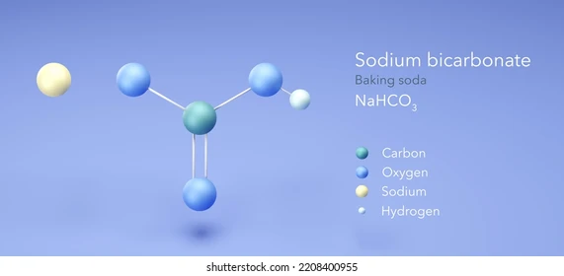
Hypothesis
Increasing the initial mass of NaHCO₃ (s) (1 gram, 3 grams, 3.03 grams, 4 grams, 5 grams, 5.01 grams) added to an evaporating dish on a hot plate will result in a proportional increase in both the Na₂CO₃ (s) produced and the mass loss of the system in the form of CO₂ (g) and H₂O (g) escaping the evaporating dish and dispersing into the surrounding air. This is due to the stoichiometric nature of the equation describing this reaction due to heat:
2NaHCO₃(s) → Na₂CO₃(s) + CO₂(g) + H₂O (g)
which demonstrates that if one side of the equation were to be increased, the other side would also increase proportionally, or in practical terms, if more reactants were included in the reaction, more product would be produced.

Variables
Variable | Type of variable | How it is measured or controlled
Amount of baking soda | Independent | The amount of baking soda used in each trial is measured in grams, with a ~1 gram difference in the amount of salt per cup
Mass of Na₂CO₃ produced (mass loss) | Dependent | The mass of the material in the evaporation dish after heating is measured to determine the mass loss of the system, which is characterized by the escaping gas that results from the heating
Heat-resistant surface | Control | The heat-resistant surface (classroom tables) were all of the same make, ensuring consistency
Brand of baking soda | Control | All of the baking soda used in the experiment, across all of the trials were of the same brand, to ensure consistency in the properties of the baking soda
Ambient temperature of the room | Control | The ambient temperature of the room was kept the same to ensure a stable experimentation environment

Materials
- Sodium bicarbonate (baking soda) - varying masses from 1.0 g to 5.0 g (inclusive)
- Evaporating dish (heat-resistant)
- Hot plate
- Heat-resistant gloves or tongs
- Electronic balance (±0.01 g)
- Heat-resistant mat
- Stirring rod (glass or heat-resistant)
- Stopwatch or timer
- Lab PPE (optional)

Procedure
- Part A: Preparation
  - Measure and record the mass of a clean, dry evaporating dish
  - Add your assigned mass of sodium bicarbonate to the dish (2.0-5.0 g range)
  - Measure and record the combined mass of evaporating dish and sodium bicarbonate
  - Spread the powder evenly across the bottom of the dish
- Part B: Initial Heating
  - Turn the hot plate to medium heat (setting 5-6 out of 10)
  - Place the evaporating dish on the hot plate
  - Heat for 15-18 minutes, stirring gently every 3-4 minutes
  - Watch for bubbling as CO₂ and H₂O are released (this is normal)
  - Continue heating until no more bubbling occurs
  - The powder may clump slightly but should remain white
- Part C: Final Heating
  - Increase heat to medium-high (setting 6-7) for 3-4 minutes to ensure complete decomposition
  - Turn off the hot plate
  - Using gloves or tongs, carefully remove the dish and place it on a heat-resistant mat
  - Allow to cool for 5-6 minutes until safe to handle
- Part D: Final Mass and Data Sharing
  - Measure and record the final mass of evaporating dish and product
  - Record your data on the class data table for graphing (on Google Sheets)
  - Calculate the mass of sodium carbonate produced
- Part E: Cleanup (10 minutes)
  - The product (sodium carbonate) can be rinsed down the drain with water
  - Clean and dry the evaporating dish
Safety and Disposal Considerations
- Wear safety goggles and lab apron throughout the experiment
- Use heat-resistant gloves when handling hot evaporating dishes
- Hot plates remain hot for several minutes after turning off
- Never touch a hot plate surface or evaporating dish with bare hands
- Keep flammable materials away from the hot plate
- Tie back long hair when working with heat sources
- Both sodium bicarbonate and sodium carbonate are safe, non-toxic household chemicals
- Waste can be rinsed down the drain

Experimental Setup
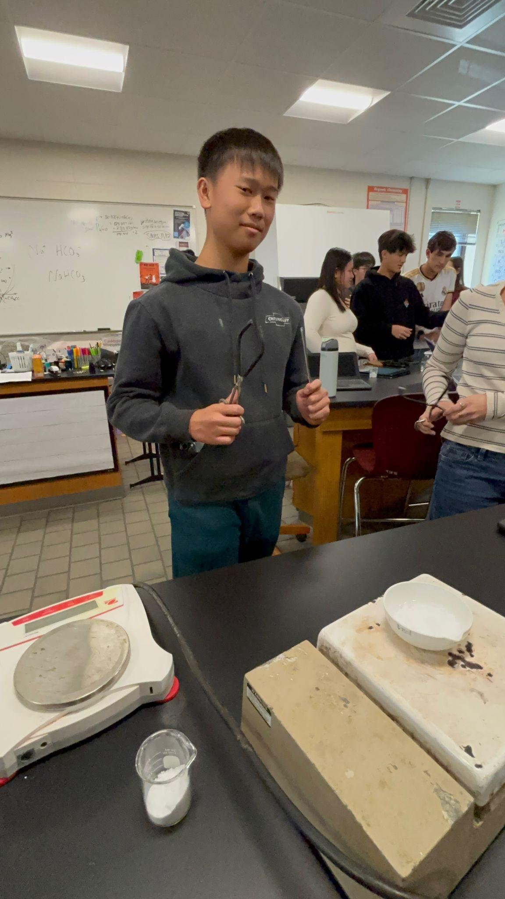

Data

Initial mass of NaHCO₃ (g) | Mass of Na₂CO₃ produced (g)
1 | 0.61
1 | 0.50
3 | 1.98
3 | 1.86
3.03 | 1.89
4 | 2.59
4 | 2.40
5 | 3.16
5.01 | 2.88
5 | 3.13

Initial mass of NaHCO₃ (g) | Mass loss (g)
1 | 0.39
1 | 0.50
3 | 1.02
3 | 1.14
3.03 | 1.14
4 | 1.41
4 | 1.60
5 | 1.86
5.01 | 2.13
5 | 1.87
Qualitative Observations
- Baking soda, when added to the evaporation dish, had many clumps, but during heating, the clumps broke up, and after heating, there were no clumps left
- After heating, the baking soda had slight “pits”
- During heating, gas was visible exiting the evaporation dish into the surrounding air
Quantitative Observations:
- Throughout all of the trials, the values increased at a rather constant rate without many outliers other than the trial which resulted in a negative mass loss and mass of product, and was thus omitted

Calculations
- Masses
  - Mass of sodium bicarbonate = (mass of dish + NaHCO₃) - (mass of dish)
    - Initially measured in increments of ~1 gram
  - Mass of product (sodium carbonate) = (final mass) - (mass of dish)
    - Initial mass of 1 gram:
      - 54.33g - 53.72g = 0.61g
      - 47.6g - 46.8g = 0.50g
    - Initial mass of 3 grams:
      - 75.41g - 73.43g = 1.98g
      - 70.04g - 68.18g = 1.86g
    - Initial mass of 3.03 grams:
      - 57.19g - 55.3g = 1.89g
    - Initial mass of 4 grams:
      - 61.83g - 59.24g = 2.59g
      - 57.3g - 54.9g = 2.40g
    - Initial mass of 5 grams:
      - 57.78g - 54.62g = 3.16g
      - 56.16g - 53.03g = 3.13g
    - Initial mass of 5.01 grams:
      - 47.76g - 44.88g = 2.88g
  - Mass loss = (mass of NaHCO₃) - (mass of product)
    - Initial mass of 1 gram:
      - 1.00g - 0.61g = 0.39g
      - 1.00g - 0.5g = 0.50g
    - Initial mass of 3 grams:
      - 3.00g - 1.98g = 1.02g
      - 3.00g - 1.86g = 1.14g
    - Initial mass of 3.03 grams:
      - 3.03 - 1.89 = 1.14g
    - Initial mass of 4 grams:
      - 4.00g - 2.59g = 1.41g
      - 4.0g - 2.4g = 1.60g
    - Initial mass of 5 grams:
      - 5.00g - 3.16g = 1.84g
      - 5.00g - 3.13g = 1.87g
    - Initial mass of 5.01 grams:
      - 5.01g - 2.88g = 2.13g
- Empirical Formula Determination
  - Using the trial of 4g initial baking soda (Lukas Aung, Audrey Kirkland, Hollyn Mandel):
    - Mass of Na in product = 2.40g x 0.4338g = 1.041g
    - Mass of CO₃ = 2.40g - 1.041g = 1.359g
    - Moles of Na = (1.041g Na)/(22.99g/mol) = 0.0453mol Na
    - Moles of CO₃ = (1.359g CO₃)/(60.01g/mol) = 0.0226mol CO₃
    - Mole ratio:
      - 0.0453mol Na/0.0226mol = ~2
      - 0.0226mol CO₃/0.0226mol = 1
    - Empirical formula: Na₂CO₃
- Alternative Analysis: Decomposition Stoichiometry
  - Using the trial of 4g initial baking soda (Lukas Aung, Audrey Kirkland, Hollyn Mandel):
    - Theoretical mass loss = mass of H₂O + mass of CO₂ released
      - 2 mol NaHCO₃ → 1 mol H₂O + 1 mol CO₂
      - (mol NaHCO₃ ÷ 2) × (18.02 + 44.01) g/mol
        - Mol NaHCO₃ = initial mass/molar mass
        - Mol NaHCO₃ = 4.00g/(22.99 + 1.01 + 12.01 + 3(16))g/mol
        - Mol NaHCO₃ = (4.00/84.01) mol
        - Mol NaHCO₃ = 0.0476 mol
      - (0.0476/2)$×$(62.03)g
      - 1.478g
    - Actual mass loss = initial mass - final mass
      - Actual mass loss = 4.00g - 2.40g
      - Actual mass loss = 1.60g
    - The theoretical mass loss of the reaction is 1.478g, while the actual mass loss of the reaction is 1.60g, with the two being in close relation to each other, further verifying the results of this lab.
Data Analysis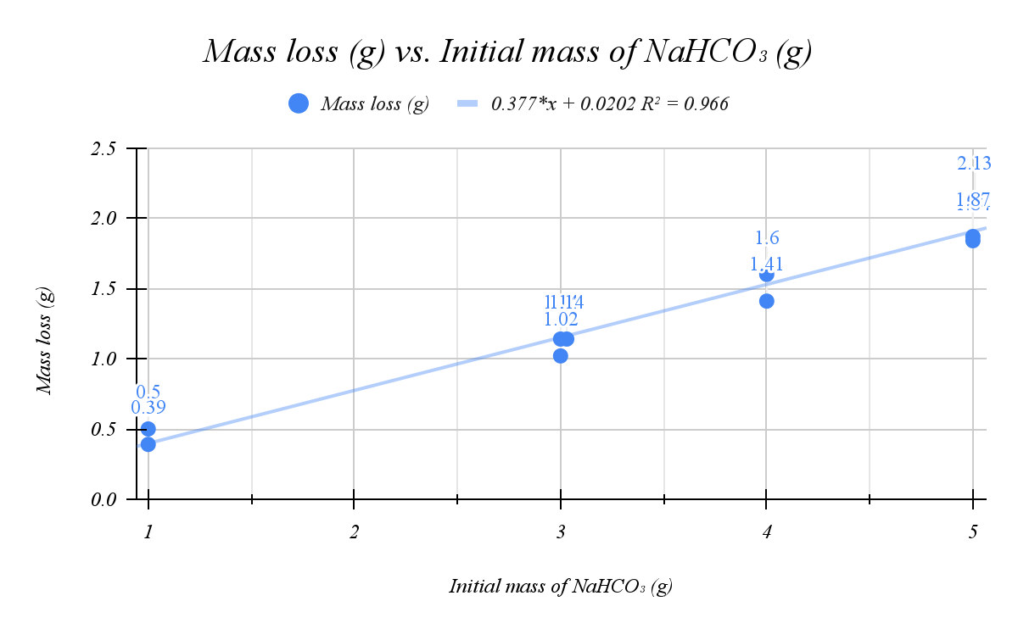

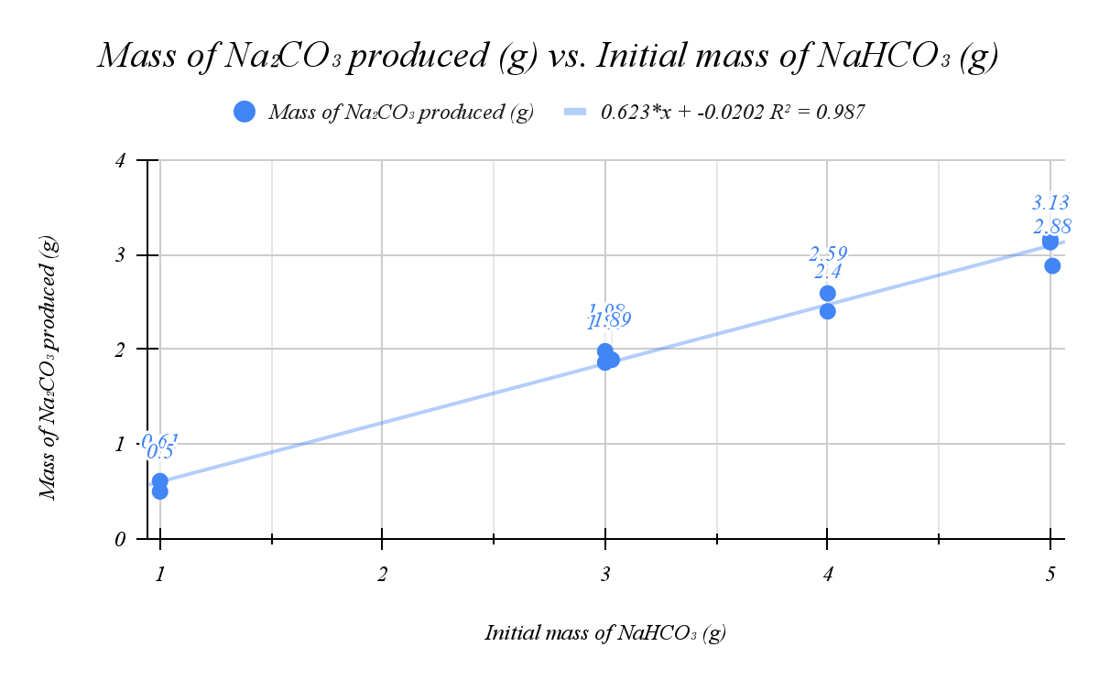Interpretation
- Mass of Na₂CO₃ produced (g) vs. Initial mass of NaHCO₃ (g):
  - The graph showcases a proportional relationship between the mass of Na₂CO₃ produced and the initial mass of NaHCO₃
  - The proportional relationship with a very high R² value experimentally proves the stoichiometric nature of the chemical reaction
2NaHCO₃(s) → Na₂CO₃(s) + CO₂(g) + H₂O (g)
- Mass loss (g) vs. Initial mass of NaHCO₃ (g):
  - The graph showcases a proportional relationship between the mass loss of the system and the initial mass of NaHCO₃
  - The proportional relationship with a very high R² value further proves the stoichiometric nature of the chemical reaction

Conclusion
This experiment demonstrated a clear and measurable relationship between both the mass of sodium carbonate produced versus the initial mass of sodium bicarbonate and the mass loss of the system versus the initial mass of sodium bicarbonate, supporting the hypothesis that an increased amount of NaHCO₃ will result in both an increased amount of Na₂CO₃ and mass loss due to CO₂ and H₂O leaving the system and dispersing into the air.
Quantitatively, the sodium carbonate produced increased from a minimum of 0.5g with an initial mass of 1g of sodium bicarbonate to a maximum of 3.16g with an initial mass of 5g of sodium bicarbonate. The mass loss due to escaping gas also increased from a minimum of 0.5g with an initial mass of 1g of sodium bicarbonate to a maximum of 2.13g of mass loss with an initial mass of 5.01g of sodium bicarbonate. These rather significant changes in mass illustrate how increases in the initial mass of the system lead to increased products, with the chemical reaction itself being caused by heat. This also further reinforces the stoichiometric character of the equation demonstrating the chemical reaction,
2NaHCO₃(s) → Na₂CO₃(s) + CO₂(g) + H₂O (g)
Qualitatively, it was observed that, when added to the evaporating dish, the NaHCO₃ had many clumps. During heating, the aforementioned clumps started to break apart, and gas was visible exiting the evaporating dish. After the heating had finished, there was little to none of the clumps still visible, and small “pits” in the Na₂CO₃ were visible.
The graph of Mass of Na₂CO₃ produced (g) vs. Initial mass of NaHCO₃ (g) reveals a very clear linear trend, indicating a directly proportional relationship between mass of sodium carbonate produced and the initial mass of sodium bicarbonate. As the initial mass of the sodium bicarbonate increased, the sodium bicarbonate produced increased at a consistent rate, which supports the prediction made by the stoichiometric nature of the chemical reaction. The calculated coefficient of determination, R² = 0.987, signifies an exceptionally strong correlation between the two variables. This means that 98.7% of the variation in sodium carbonate produced can be explained by changes in the initial mass of the sodium bicarbonate, confirming the reliability of the data.
The graph of Mass loss (g) vs. Initial mass of NaHCO₃ (g) also reveals a very clear linear trend with a directly proportional relationship between the mass loss of the system due to escaping carbon dioxide and water vapor and the initial mass of sodium bicarbonate. Similar to the previous graph, the stoichiometric characteristic of the chemical reaction is demonstrated through the high coefficient of determination, R² = 0.966, which signifies a very strong correlation between the two variables, further confirming the reliability of the data.
The calculated empirical formula that was determined for the product was Na₂CO₃. This is the exact same as the molecular formula of sodium carbonate, and thus, is completely accurate. The linear relationships in the graphs show a clear, proportional relationship between the Na₂CO₃ produced in grams and mass loss of the system in grams vs the initial amount of NaHCO₃. As the initial mass increases, both the product produced and the mass lost through the escaping CO₂ and water vapor increase proportionally, albeit in their own respective slopes.
The slope of Na₂CO₃ produced (g) vs. Initial mass of NaHCO₃ (g), as indicated by the equation of the trendline, is 0.623. The theoretical slope of this relationship is 0.631, showing that the experimental data is reliable due to the similarity in these slopes. Similarly, the slope of Mass loss (g) vs. Initial mass of NaHCO₃ (g), is 0.377, which is very close to the theoretical slope of the relationship, further proving the accuracy of the data. The different initial masses, in this case, ~1g, ~3g, ~4g, and ~5g helped verify the Law of Definite Proportions by proving that the ratio between the elements remained the same regardless of the initial mass, which is a core principle of the Law of Definite Proportions.
These findings are further supported by demonstrations such as Flinn Scientific’s (2012) and Victor Chen’s (Chen, 2020), which reached similar results to this lab, reinforcing the results of this investigation. Mahesh Shenoy’s lesson on decomposition reactions explains how decomposition reactions work (Shenoy). A real world example of this chemical decomposition is the making of “baked baking soda,” which is sodium carbonate used in cooking to create a stronger alkaline solution compared to normal baking soda, giving pretzels their signature dark, browned crust of pretzels and giving noodles a chewier texture (McGee, 2010.). Many online recipes for the so-called “baked baking soda” are essentially exact replicas of this experiment. Together, these examples validate the lab’s results and highlight the broader relevance of chemical decomposition and stoichiometry across both educational and practical contexts.

Evaluation
Several sources of error may have affected this investigation. Random errors could include incomplete decomposition due to insufficient heating, the loss of product due to slight human error such as accidental spilling, or inconsistent heating on the hot plate. Systemic errors might stem from uncalibrated or faulty equipment, such as an inaccurate scale. To reduce random error, one could have increased the heating time in order to ensure that the decomposition would finish completely, taken multiple measurements in order to reduce the effect of potential outliers due to human error, and used hot plates that did not have any uneven heating or moved the evaporating dish around the hot plate every minute or so to have contact with more than just one spot of the hot plate. To reduce systemic errors, once could use newer, calibrated equipment. An example of a major random error was the trial of 2.0g of sodium bicarbonate, which was omitted from this lab due to not having sensible results. This specific trial resulted in a final mass of the evaporating dish and the sodium bicarbonate less than the initial mass of the evaporating dish itself, which is not possible. Overall, despite this major error which occurred in only one trial and other less significant errors that occurred in a majority of the trials, while this experiment successfully demonstrated the concept of chemical decomposition and stoichiometric reactions, it could be improved by refining the methodology in order to enhance its scientific rigor.

References:
31 experiment 7 - thermal decomposition of sodium bicarbonate introduction. (n.d.). https://alameda.edu/wp-content/uploads/2023/07/Chem-1A-Exp.-7-Decomposition-of-Sodium-Carbonate.pdf
Anne Marie Helmenstine, Ph. D. (2019, December 12). Equation for the decomposition of sodium bicarbonate (baking soda). ThoughtCo. https://www.thoughtco.com/decomposition-equation-for-baking-soda-604045
Birazian, S. (2021, February 3). Decomposition of baking soda. YouTube. https://www.youtube.com/watch?v=JNHxbns4THs
Chen, V. (2020, September 18). Sodium Bicarbonate Decomposition Home Lab. YouTube. https://www.youtube.com/watch?v=U0uZ7QGFUds
FlinnScientific. (2012, December 17). Decomposition of Baking Soda. YouTube. https://www.youtube.com/watch?v=mMVr7XC9_5Y
fullpdfword.org. (n.d.). Www.mcsprogram.org - decomposition of Sodium Bicarbonate Lab Report. decomposition of sodium bicarbonate lab report. https://www.mcsprogram.org/fetch.php/u306F4/244227/Decomposition Of Sodium Bicarbonate Lab Report.pdf
Gaskin, B. (2019). Sodium Bicarbonate Decomposition Lab report - chem 101 experiment 12 - STUDOCU. Sodium Bicarbonate Decomposition Lab Report - Chem 101 Experiment 12. https://www.studocu.com/en-us/document/florida-agricultural-and-mechanical-university/general-chemistry-ii/sodium-bicarbonate-lab-report/11222877
Libretexts. (2023, June 30). Stoichiometry and balancing reactions. Chemistry LibreTexts. https://chem.libretexts.org/Bookshelves/Inorganic_Chemistry/Supplemental_Modules_and_Websites_(Inorganic_Chemistry)/Chemical_Reactions/Stoichiometry_and_Balancing_Reactions
Libretexts. (2025a, March 21). 11.5: Decomposition reactions. Chemistry LibreTexts. https://chem.libretexts.org/Bookshelves/Introductory_Chemistry/Introductory_Chemistry_(CK-12)/11%3A_Chemical_Reactions/11.05%3A_Decomposition_Reactions
Libretexts. (2025b, November 5). 9: Lab 9 - decomposition of baking soda. Chemistry LibreTexts. https://chem.libretexts.org/Courses/Triton_College/Fundamentals_of_Chemistry_%28Lab_Manual%29/09%3A_Decomposition_of_Baking_Soda
McGee, H. (2010, September 14). For old-fashioned flavor, bake the baking soda (published 2010). For Old-Fashioned Flavor, Bake the Baking Soda. https://www.nytimes.com/2010/09/15/dining/15curious.html
O’Connor, K. (2011, September 18). Lab 1.1 Heating Baking Soda. YouTube. https://www.youtube.com/watch?v=VjWqs1o2J0c
Shenoy, M. (n.d.). Decomposition reactions (video) | Kahn Academy. Khan Academy. https://www.khanacademy.org/science/physical-chemistry-essentials/x98cdf762ed888601:redox-reactions/x98cdf762ed888601:types-of-redox-reactions/v/decomposition-reactions
Spaeth, S. (2025, March 14). Baked baking soda (sodium carbonate) recipe. Serious Eats. https://www.seriouseats.com/baked-baking-soda
YouTube. (n.d.). Decomposition of Sodium Bicarbonate (Baking Soda). YouTube. https://www.youtube.com/watch?v=sESGyRPnQxI

